

v

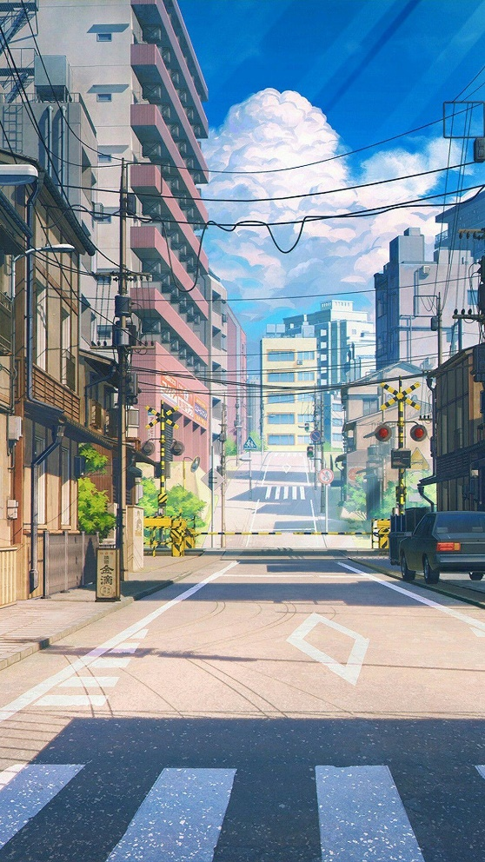

RPG Video Game

final project

Haramain Emir Ben | Algorithm and Programming | ID: 2602206770

## Brief Description

In this report, my final project for the algorithm and programming course I choose to create a video game, because I have no ideas left and, in my mind, this is only the option for me to make.

For this project I created an RPG style video game where you can move around and encounter enemies on the map, and if you touched the enemies you will die, and you will be sent to a game over screen but you can also restart.

You also can attack an enemy and doing that will lead to the enemy disappear or killed to be exact.

## Use case Diagram

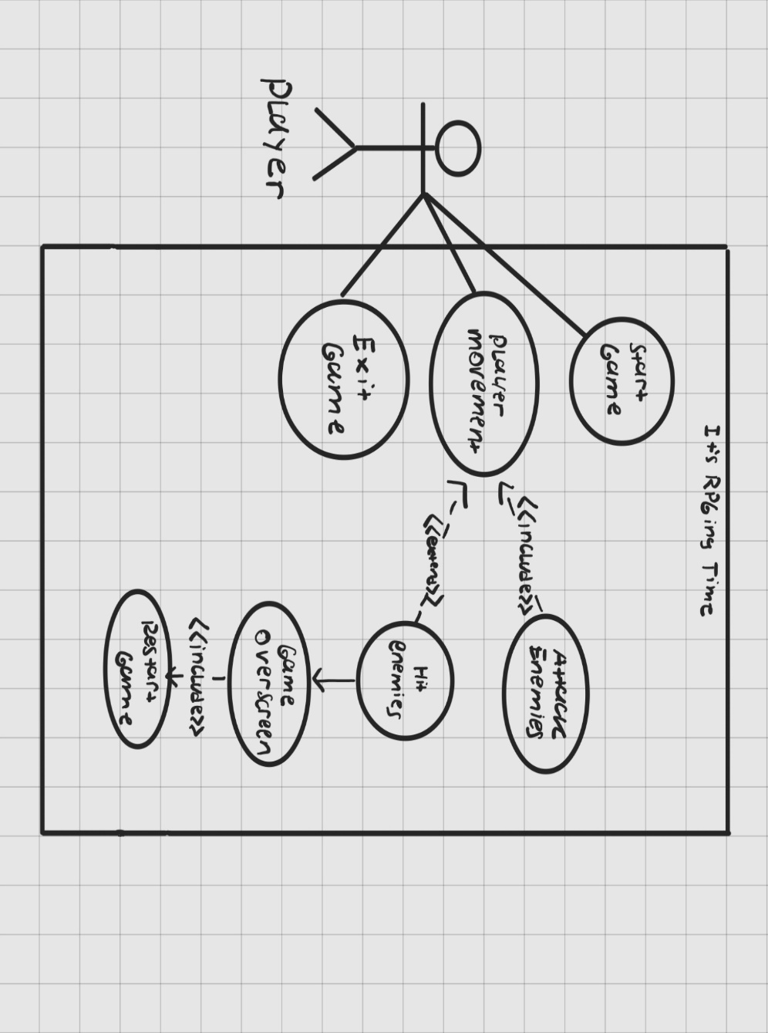

This is the Use case diagram for my Game project and in here it is explained that my program allows the player to attack the enemies and got hit by the enemy or in this case collide which result the game to be over, but you are able to restart the game every time you lost.

## Activity Diagram

## Class Diagram

## Modules

Here are the modules that I used in my program.

* PyGame

Pygame is my preferred module to create this RPG game because it is the one where I am most familiar because it is what I learned my class on university.

The Python programming language can **be used to create multimedia applications like video games** using the cross-platform Pygame package, which is free and open source. It employs a straightforward DirectMedia Layer library as well as numerous other well-known libraries to abstract the most typical functionalities, making it easier to write these apps.

* Sys

The sys module in Python **provides various functions and variables that are used to manipulate different parts of the Python runtime environment**. It allows operating on the interpreter as it provides access to the variables and functions that interact strongly with the interpreter.

By using a sys modules, you can use it for ending the program, but more importantly the module has a relevance with pygame so I always use this module if I were to create a game using pygame nonetheless. For example: pygame can use the SysFont to render any available sys modules ’font.

* Math

The Python 3 standard library includes a built-in module called math that offers common mathematical constants and functions. Numerous mathematical operations, including numerical, trigonometric, logarithmic, and exponential computations, can be carried out with the math module.

Basically, you can implement a mathematical equation inside your code. Such as constant provided by the math module. For Example:

* Pi
* Infinity
* Not a Number (NaN)

Having such constant saves the time writing the value of each constant every time we want to use it and that too with great precision.

* Random

A Python built-in module called Python Random is used to create random integers. These numbers are not actually random because they are pseudo-random. This module can be used to generate random numbers, print a random value for a list or string, and do other random operations.

For Example :

* randint() = returns a random number between the given range

## Essential Algorithms

## Screenshots

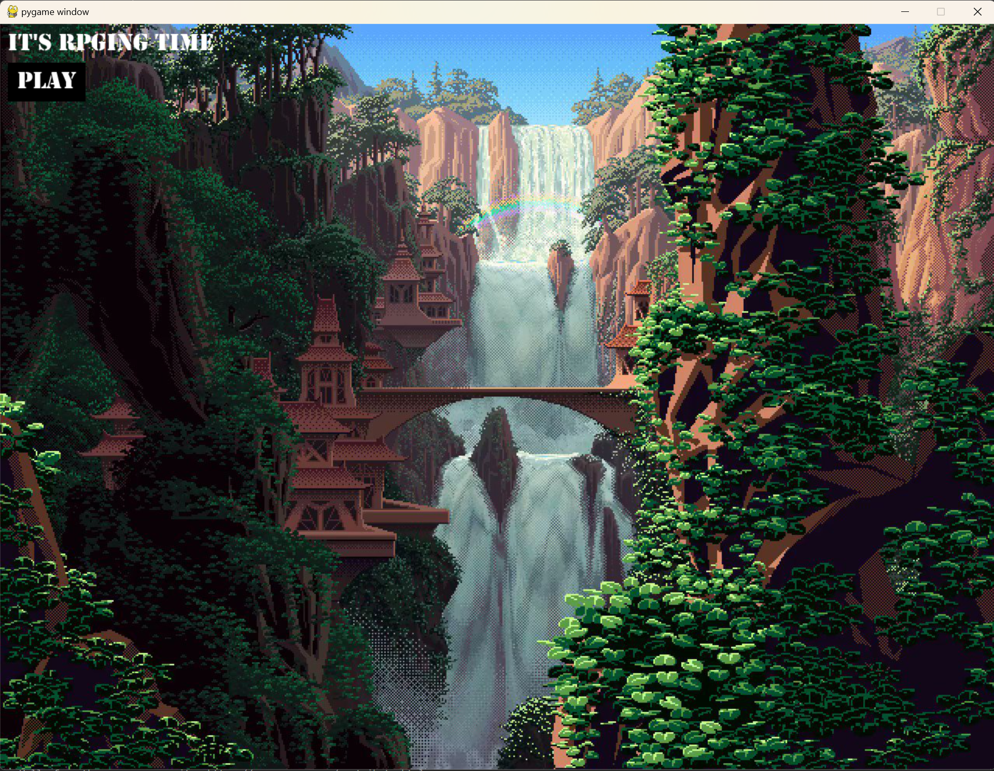

The Intro Screen, once you press the Play button Below the Title you can play the game, or you can press the X button on the window to exit anytime.

This is the gameplay you can move around the map as much as you want but watch out for the enemies because if you got caught you will be sent to the game over screen.

The enemies are the green skinned sprite that looks exactly like your character and they’re moving randomly, you can attack them which leads them to disappear.

And this is the Game over screen where you can try again and retry the game again by pressing the Try Again Button on the Bottom Left corner there on the Screenshot.

## Reflection

I learned something about pygame module which is a collection of libraries that contain tons of functions that can be used to create a game which is a back and forth searching when i were to create a game similar to mines.

I learned a lot from making this game, from making classes and functions inside of the class, at first I was not very confident in my skills as a programmer in the making especially in this case it is about game development which is the reason for me for taking this course in the first place.

I’ve got to give a lot of thanks to the Youtuber named ShawCode in helping me try to create a game using PyGame.

In this case I learned about how to manipulate the window screen by changing the aspect ratio in the config.py file and it corresponds to the tilesize as well for determining the amount of sprites inside the tilemap which is just to divide the window height and width with the Tilesize.